Franklin COMP 294

Practicum Project Weekly Status Report

Name: Christa Fox

Course Number: COMP294-R1WW (F17)

Project Name: F17Gradebook

Week Number: 6

Progress for the week

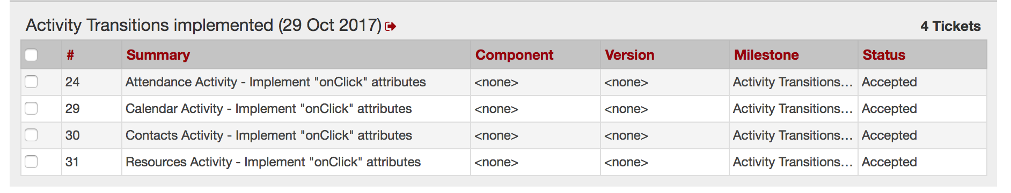

* Accepted tickets 24, 29, 30, and 31 on October 15, 2017.

Problems Solved

* Even though I had committed my changes to the xml files from last week the push was not successful, and I was not aware of this until our meeting on Google hangouts on October 15, 2017.
* I shared my screen and Lisa and Justin were able to assist me in finding and deleting a file in the .idea folder that was preventing me from pushing to the master branch.
* We had planned to build each part of the application after the database was completed, but Lisa broke it into more pieces to have something to show for the presentation Tuesday.

Communication

* Unfuddle: accepted 4 tickets
* Pulled from the repository
* Committed changes
* Used text/email
* Google hangout messages and meet October 15, 2017

Goals for next week

* Complete the java code to be able to click through the xml files for the presentation Tuesday.
* Run through the presentation Tuesday at 3:30 PM.
* Attend the presentation At 5:00PM
* Accept and start the full build later this week.